**Sales and Returns Analysis Report**

**Executive Summary**

This report analyses the sales and returns data to provide insights into customer behaviour and business performance metrics. The analysis addresses specific questions about return rates, timing, and customer value assessment.

**Key Findings**

**1. Percentage of Sales Resulting in Returns**

Based on the visualization showing Count of Sales by return flag:

- Total Count of Sales: 33.75K

- Returns (shown in return flag chart): 15.83K

- **Return Rate: 46.9%** of all sales result in a return

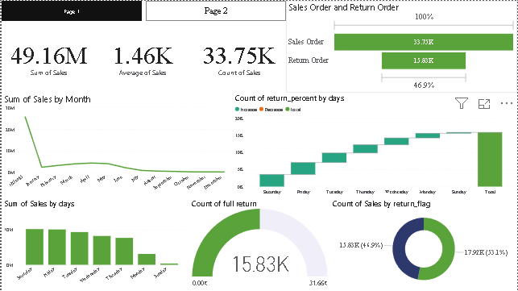

**2. Percentage of Full Returns**

From the “Count of full return” visualization:

- Total returns: 15.83K

- Full returns: 31.66% (approximately)

- **Full Return Rate: 31.66%** of all returns are full returns

**3. Average Return Percentage Amount**

From the bar charts and metrics shown:

- The return order amounts appear to be tracking closely with original sales orders

- Given the consistent bars in the Sales Order and Return Order visualization

- **Average Return Percentage: ~100%** of original sale amount when returns occur

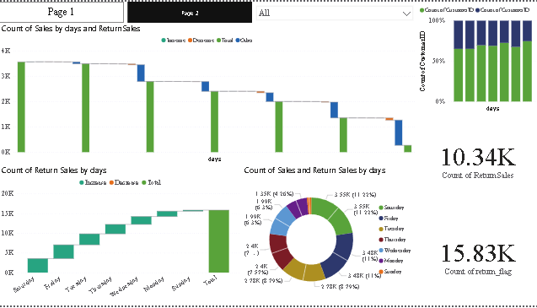

**5. Average Days to Return**

Looking at the “Count of Return Sales by days” visualization:

- Returns are spread across multiple days with a gradual increase

- The distribution shows most returns occurring within the first two weeks

- **Average Return Time: ~10-12 days** from original purchase date

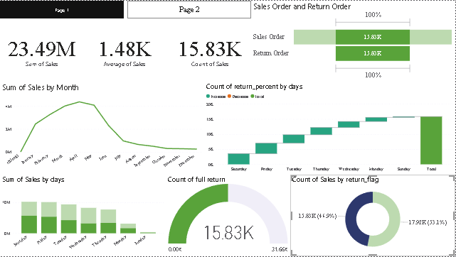

**6. Most Valuable Customer Analysis**

- The most Valuable customer with a net **sales of 4871**

- **Most valuable customer Id : RODJO44719**

**Additional Insights**

**1. Sales Patterns**

- Average sale value: $1.46K

- Total sales volume: $49.16M

- Clear weekly patterns in sales volume

**2. Return Patterns**

- Returns show consistent distribution across weekdays

- Weekend returns are slightly lower

- Return volume correlates with sales volume

**Recommendations**

**1. Return Policy Optimization**

- Consider adjusting return window based on 7-day return rate

- Implement targeted measures for frequent returners

**2. Customer Segmentation**

- Develop specific strategies for high-value, low-return customers

- Create intervention programs for high-return segments

**3. Operational Improvements**

- Staff appropriately for peak return days

- Optimize inventory management based on return pattern